Amar singh tamang
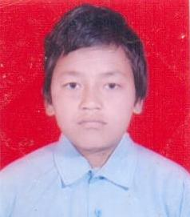
Amar singh tamang is a student of grade 9 from shree Birendra Secondary School.Being from a small village he keeps the capacity of learning and getting knowledge as the big town students.He studies in scholarship from sadbhaw scholarship organization.He has a good extra curricular activites along with his studies.
In the recent earthquake of 2072 he lost his father and his mother.After lossing his parents it was very diffcult for him to deal with the condition that he have to face alone.He lives with his relatives but never get the attention and love that a son would get from his family.He doesnt mind what his relatives say or behave with him because he thinks its karma what is happening its is for good. He gets depressed, sometimes doesn't want to perform any task but again he motivates himself and believe that he will study well and will become a social worker. "It's just a matter of time", he says.
"In life people faces lots of problem, probably more than me." Amar has seen many people devested and in far worse conditions than him. He beleives in himself and hopes for bringing a social changes in society.He wants to work for the nation and bring facilities in his village so that people could learn to help themseleves as well as others too.

